XD-S1500Z Technical Specifications

Wuhan X-Dynamics Co., Ltd.
February 2025

Revision History
Version Number | Revision Date | Revised Chapter | Revision Notes
V1.1.1 | 2025/02/27 | Entire Chapter | First edition
V1.1.2 | 2025/03/4 | Chapter 1
V1.1.3 | 2025/09/1 | Chapter 1.3 | Update some parameters and structural drawings
V1.1.4 | 2025/09/22 | Chapter 5 | Modify baud rate command

Copyright Notice
Copyright © Wuhan X-Dynamics Co., Ltd. All rights reserved.

Confidentiality Statement
The information contained in this document (including any attachments) is confidential. The recipient understands that this document is confidential and shall not be used for any purpose other than the specified purpose, nor shall it be disclosed to any third party.

Contents
1. Product Overview 4
1.1. Application Areas 4
2. Specifications and Parameters 4
2.1. Product Physical Diagram 4
2.2. Product Specifications 5
3. Structural Description and Interface Definition 6
3.1. Structural Drawings 6
3.2. Hardware Interface Definition 7
3.3. Basic Performance Measurement 7
4. Electrical Characteristics 8
4.1. Power Supply and Power Consumption 8
4.2. Reliability Standards 8
5. Control Commands 9
5.1. UART Interface 9
5.2. Control Commands 9
5.2.1. Single Measurement Command 9
5.2.2. Continuous Measurement Command 10
5.2.3. Continuous Measurement Stop Command 10
5.2.4. Baud Rate Setting (Immediate Effect) 11
5.2.5. Device Information Retrieval 11
6. Appendix 11
6.1. System Integration Guide 11
6.2. Usage Recommendations 12

XD-S1500Z Technical Specifications

Product Overview
The XD-S1500Z laser rangefinder module is developed based on a 905nm semiconductor laser, featuring a compact size, lightweight design, and long measurement range. Its applications include handheld rangefinders, micro drones, and rangefinder sights. It is equipped with a UART (TTL protocol) data transmission interface, providing upper-level software and communication protocol command sets to facilitate user-defined development.
Product Features of XD-S1500Z:
• Custom-developed high-precision calibration and calibration algorithms;
• Compact size and lightweight design;
• Long measurement range;

Application Areas
XD-S1500Z has a wide range of applications:
• Handheld rangefinders, micro drones, rangefinder sights, etc.

Specifications and Parameters

Product Physical Diagram
The actual product image is shown below:
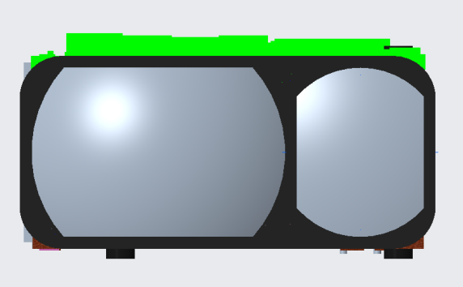

Product Specifications
The product specifications are as follows:
Name | Performance Indicators | Indicator Parameters | Remarks
key indicators | Range | 10~1500m
key indicators | Accuracy | ±1m (d≤400 meter)；  ±(d*0.4%)m (d＞400 meter）
key indicators | Distance measurement frequency | ≤2~4Hz
key indicators | Laser emission angle | 7*3mrad
key indicators | Emission aperture | 10×7.5mm
key indicators | Reception aperture | 15×10mm
key indicators | Wavelength | 905nm
key indicators | Safety level | Class I Eye safety
system parameters | Working environment | Indoor & Outdoor
system parameters | Working temperature | -30℃ ~ 60℃
system parameters | Storage temperature | -30℃ ~ 80℃
system parameters | Impact level | 1200G.1ms
system parameters | Structural dimensions | ≤24.6mm × 13.55mm × 25.72mm
system parameters | Weight | 10±0.5g
electrical | Communication interface | UART(TTL-3.3V)
electrical | Power interface | SM06B-SURS-TF(LF)(SN)
electrical | Supply voltage | DC3V~5V
electrical | Average power consumption | ≤600mW
electrical | Baud rate | 115200bps(default)

Structural Description and Interface Definition

Structural Drawings
The structural dimensions of the XD-S1500Z product are shown below:
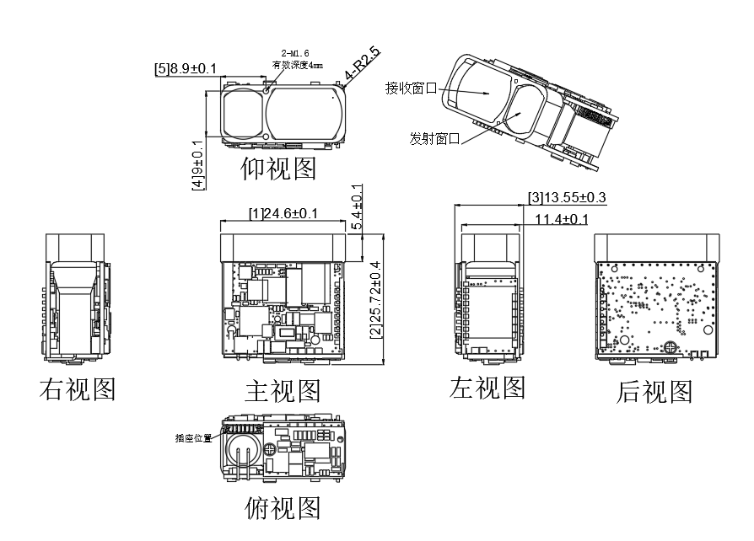

Hardware Interface Definition
The product hardware interface structure diagram is shown below:
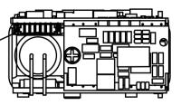
The interface specifications corresponding to the product interface diagram are shown in the table below:
- Electrical interface: UART (TTL-3.3V)
- Connector model: 6PIN 0.8mm pitch terminal
Connector wire sequence table

Pin | Definition | Description
1 | GND | Serial port ground/power ground
2 | VCC | Power supply: 3V to 5V, maximum cannot exceed 5.5V
3 | NC | NC
4 | UART_TX | Serial port transmitter, TTL 3.3V
5 | UART_RX | Serial port receiver, TTL 3.3V
6 | POWER_ON | Power switch  (High level enables power, low level turns off power, where high level is power level)

Basic Performance Measurement
The measurement range of this product is defined under the following conditions:
(1) The measurement target has moderate reflectivity: such as building walls;
(2) The measurement target's reflective surface is perpendicular to the laser emission direction;
(3) The weather conditions are clear but not under direct sunlight;

Electrical Characteristics

Power Supply and Power Consumption
The power supply and power consumption parameters of the XD-S1500Z product are shown in the table below:
Power Supply Parameters and Specifications Table
Supply voltage | DC3V~5V
Average power consumption | ≤600mW
Peak power consumption | ≤1.65W
Standby power consumption | ≤1.5 mW (EN disabled)

Reliability Standards
The reliability standard parameters for the XD-S1500Z product are shown in the table below:
Operating temperature | -30℃~60℃
Storage temperature | -30℃~80℃
Impact level | 1200G.1ms

Control Commands

UART Interface
• Baud rate: 115200 bps (default)
• Start bit: 1 bit
• Data bits: 8 bits
• Stop bit: 1 bit
• Parity bit: None
• Flow control: None

Control Commands
Transmit checksum = byte 3 + byte 4 + byte 5 + byte 6 + byte 7;
Receive checksum = byte 1 + byte 2 + byte 3 + byte 4 + byte 5 + byte 6 + byte 7;

Single Measurement Command
- The single measurement command is as follows；
Single measurement command
Byte 1 | Byte 2 | Byte 3 | Byte 4 | Byte 5 | Byte 6 | Byte 7 | Byte 8
0x55 | 0xAA | 0x88 | 0xFF | 0xFF | 0xFF | 0xFF | checksum

Single measurement return value
Byte 1 | Byte 2 | Byte 3 | Byte 4 | Byte 5 | Byte 6 | Byte 7 | Byte 8
0x55 | 0xAA | 0x88 | Status | 0xFF | DATA_H | DATA_L | checksum
Status = 0，Single measurement failure； DATA_H=0xFF，DATA_L=0xFF； Status = 1，Single measurement success；DATA_H=High byte of measurement result；DATA_L=Measurement result low byte；

Continuous Measurement Command
- The continuous measurement command is as follows:；
Continuous measurement command
Byte 1 | Byte 2 | Byte 3 | Byte 4 | Byte 5 | Byte 6 | Byte 7 | Byte 8
0x55 | 0xAA | 0x89 | 0xFF | 0xFF | 0xFF | 0xFF | checksum

Continuous Measurement Return Values
Byte 1 | Byte 2 | Byte 3 | Byte 4 | Byte 5 | Byte 6 | Byte 7 | Byte 8
0x55 | 0xAA | 0x89 | Status | 0xFF | DATA_H | DATA_L | checksum
Status = 0，Multiple measurement failures； DATA_H=0xFF，DATA_L=0xFF； Status = 1，Multiple measurements successful；DATA_H=High byte of measurement result；DATA_L=Measurement result low byte；

Continuous Measurement Stop Command
- The continuous measurement stop command is as follows；
Continuous measurement stop command
Byte 1 | Byte 2 | Byte 3 | Byte 4 | Byte 5 | Byte 6 | Byte 7 | Byte 8
0x55 | 0xAA | 0x8E | 0xFF | 0xFF | 0xFF | 0xFF | checksum

Return value when continuous measurement stops
Byte 1 | Byte 2 | Byte 3 | Byte 4 | Byte 5 | Byte 6 | Byte 7 | Byte 8
0x55 | 0xAA | 0x8E | Status | 0xFF | 0xFF | 0xFF | checksum
Status = 0，Close multiple measurement failures； Status = 1，Close multiple measurements successful；

Baud Rate Setting (Immediate Effect)
Baud rate transmission settings
Byte 1 | Byte 2 | Byte 3 | Byte 4 | Byte 5 | Byte 6 | Byte 7 | Byte 8
0x55 | 0xAA | 0x01 | 0xFF | 0xFF | 0xFF | 0x01 | checksum
Byte 7，Byte 8：
0x01,0xFF——Baud Rate 9600bps；0x02,0x00——Baud Rate 14400bps；
0x03,0x01——Baud Rate 19200bps；0x04,0x02——Baud Rate 38400bps；
0x05,0x03——Baud Rate 57600bps；0x06,0x04——Baud Rate 115200bps；
0x07,0x05——Baud Rate 128000bps；0x08,0x06——Baud Rate 230400bps；

Baud rate setting return
Byte 1 | Byte 2 | Byte 3 | Byte 4 | Byte 5 | Byte 6 | Byte 7 | Byte 8
0x55 | 0xAA | 0x01 | Status | 0xFF | 0xFF | 0x01 | checksum
Status=0x00，Baud rate setting failed； Status=0x01，Baud rate setting successful；
0x01——Baud rate 9600bps；0x02——Baud rate 14400bps；0x03——Baud rate 19200bps；
0x04——Baud rate 38400bps；0x05——Baud rate 57600bps；0x06——Baud rate 115200bps；
0x07——Baud rate 128000bps；0x08——Baud rate 230400bps；

Device Information Retrieval
Device Information Retrieval
Byte 1 | Byte 2 | Byte 3 | Byte 4 | Byte 5 | Byte 6 | Byte 7 | Byte 8
0x55 | 0xAA | 0xA0 | 0xFF | 0xFF | 0xFF | 0xFF | checksum

Device information retrieval return
Byte 1 | Byte 2 | Byte 3 | Byte 4 | Byte 5 | Byte 6 | Byte 7 | Byte 8 | Byte 8
0x55 | 0xAA | 0xA0 | Status | 0xFF | 0x58 | 0x44 | 0x02 | checksum
Status=0x00，Device information retrieval return； Status=0x01，Device information retrieved successfully；

Power-on startup completion information

Power-on startup completion information
Byte 1 | Byte 2 | Byte 3 | Byte 4 | Byte 5 | Byte 6 | Byte 7 | Byte 8
0x55 | 0xAA | 0xA1 | 0xFF | 0xFF | 0xFF | 0xFF | checksum

Appendix

System Integration Guide
Before selecting the XD-S1500Z camera for development, please contact Wuhan X-Dynamics Co., Ltd. to obtain technical specifications and other relevant information. Through preliminary evaluation, debugging, and verification, you can determine whether it meets mass production requirements.
Recommended Process:
• Read the XD-S1500Z Technical Specifications;
• Purchase and obtain an XD-S1500Z sample unit through official channels;
• Contact personnel from Wuhan Jidong Intelligent Technology Co., Ltd. prior to development to obtain relevant materials;
• Select an appropriate development platform based on your needs;
• Develop the product according to its functional requirements. If any issues arise during the development process, please contact Jidong Intelligent staff promptly;
• Finalize the mass production plan for the final product.

Usage Recommendations
Factors affecting ranging capability and accuracy include:
- ➢Target reflectivity: Generally, the higher the target reflectivity, the better the ranging capability and the faster the response speed. For example, targets with medium reflectivity can be measured up to 1500 m, while targets with low reflectivity may only be measured up to 800 m.
- ➢Measurement angle: When the laser angle is perpendicular to the target, the ranging capability is better and the response speed is faster; otherwise, it decreases. Under extreme conditions, it cannot be guaranteed that the ranging capability and response speed specified in this manual can be achieved.
- ➢Measurement environment: Factors affecting ranging capability and response speed also include sunlight intensity, the concentration of water vapor and suspended particles in the air, and the angle deviating from direct sunlight.

