XD-S2000Z Technical Specification Document

Wuhan X-dynamics Technology Co., Ltd.
March 2025

Revision History

version number | Revision date | Revision Chapter | revision note
V1.1.0 | 2025/8/15 | Full Chapter

Copyright Statement
Copyright © Wuhan X-dynamics Technology Co., Ltd. All rights reserved.

declaration of secrecy
The information contained in this document (including any attachments) is confidential. Recipients acknowledge that the document they receive is confidential and may not be used for any purpose other than those specified herein, nor may they disclose the document to any third party.

catalogue
1. Product Overview
1.1. Application Fields
2. Specification Parameters
2.1. Product Physical Image
2.2. Product Specifications
3. Structural Description and Interface Definition
3.1. Structural drawings
3.2. Hardware Interface Definition
3.3. Basic Performance Testing
4. Electrical Characteristics
4.1. Power Supply and Power Consumption
4.2. Reliability Criteria
5. Control Instructions
5.1. UART Interface
5.2. Control Instructions
5.2.1. Single Measurement Command
5.2.2. Continuous Measurement Command
5.2.3. Continuous Measurement Stop Command
5.2.4. Port Rate Configuration (Effective Immediately)
5.2.5. Equipment Information Acquisition
5.2.6. Power-on Start-up Completion Information
6. Appendix
6.1. System Integration Guide
6.2. Usage Recommendations

XD-S2000Z Technical Specification Document

Product Overview
The XD-S2000Z laser ranging module, developed with a 905nm semiconductor laser, features a compact design, lightweight construction, and extended measurement range. It is widely used in handheld rangefinders, micro drones, and ranging scopes. The module includes a UART (TTL protocol) data transmission interface, providing software for host computers and communication protocol command sets to facilitate user customization.
Product XD-S2000Z features:
- Developing self-developed high-precision calibration and calibration algorithms;
- Compact in size and lightweight;
- The measuring distance is long;

application area
XD-S2000Z is widely used in the following fields:
- Handheld rangefinder, micro drone, rangefinder scope, etc.;

Specification parameters

Product image
The actual product is shown below:
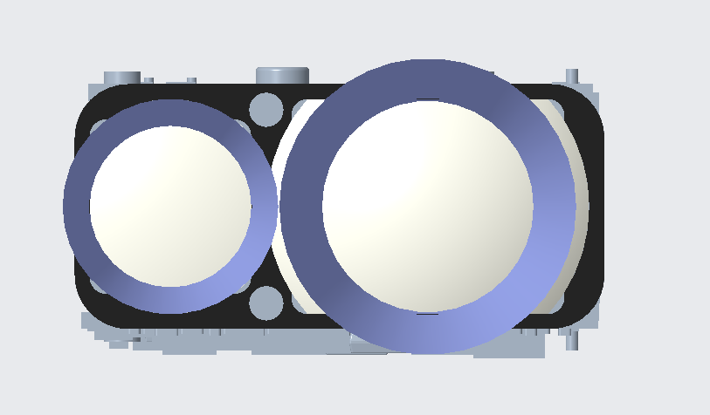
Figure 1. XD-S2000Z rendering

Product Specifications
The product specifications are as follows:
Table 1. Product Specification Table
name | performance index | Indicator parameters | remarks
key index | range | 10~2000m
key index | accuracy | ±1 m (d≤400 meters); ±1 m (d≤400 meters);  ±(d*0.4%) m (d>400 meters)
key index | range frequency | ≤1~4Hz
key index | laser emission angle | ~7*3mrad
key index | launch aperture | 10×7.5mm
key index | Receiving aperture | 15×10mm
key index | wavelength | 905nm
key index | security classification | Class I Human Eye Safety
system parameter | work environment | Indoor & Outdoor
system parameter | working temperature | -30℃ ~ 60℃
system parameter | storage temperature | -30℃ ~ 80℃
system parameter | Impact magnitude | 1200G.1ms
system parameter | structure size | ≤24.6mm × 13.55mm × 25.72mm
system parameter | weight | 10+0.5g
electrical | CI | UART(TTL-3.3V)
electrical | Power interface | SM06B-SURS-TF(LF)(SN)
electrical | service voltage | DC3V~5V
electrical | Average power consumption | ≤600mW
electrical | Baud rate | 115200bps (default)

Structure Description and Interface Definition

structural drawings
The structural dimensions of the XD-S2000Z product are shown below:
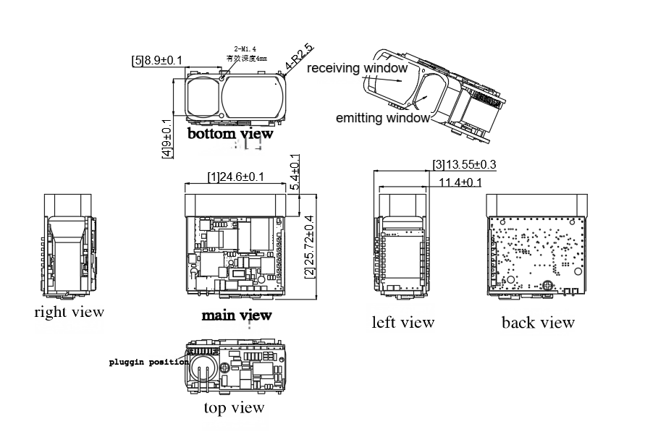
Figure 2. Dimensional diagram of XD-S2000Z

Hardware Interface Definition
The hardware interface structure diagram of the product is shown below:
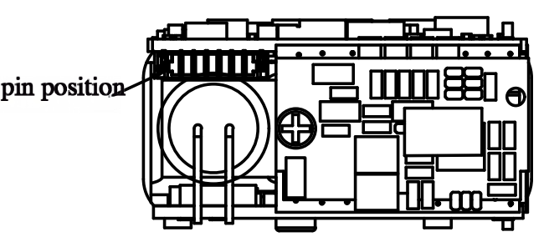
Figure 3. Product Interface Diagram
The corresponding interface specifications in the product interface diagram are shown in the table below:
- Electrical interface: UART (TTL-3.3V)
- Connector type: 6-pin, 0.8mm pitch terminals
Table 2. Connector wiring sequence table

pin | definition | explain
1 | GND | Serial port ground/power supply ground
2 | VCC | Power supply: 3V~5V, maximum 5.5V
3 | NC | NC
4 | UART_TX | Serial transmitter, TTL 3.3V
5 | UART_RX | Serial receiver, TTL 3.3V
6 | POWER_ON | mains switch  (Active on high level, off on low level, where high level refers to the power supply level)

Basic performance testing
The range of this product is defined under the following conditions:
- The target is of medium reflectivity, such as the wall of a building;
- The target reflection surface is perpendicular to the laser emission direction.
- The weather was measured as clear but not under direct sunlight;

electrical character

Power Supply and Power Consumption
The power supply and power consumption parameters of the XD-S2000Z product are listed in the table below:
Table 3. Power Supply Parameters and Specifications Table
service voltage | DC3V~5V
Average power consumption | ≤600mW
peak power consumption | ≤1.65W
Standby power consumption | ≤1.5mW (EN not enabled)

reliable prediction
The reliability standard parameters for the XD-S2000Z product are listed in the table below:
Table 4. Reliability Criteria Table
working temperature | -30℃~60℃
storage temperature | -30℃~80℃
Impact magnitude | 1200G.1ms

control instruction

UART joggle
- Baud rate: 115200bps (default)
- Start position: 1 position
- Data bits: 8 bits
- Stop bit: 1 bit
- Check digit: None
- Flow control: None

control instruction
Send the checksum = Byte 3 + Byte 4 + Byte 5 + Byte 6 + Byte 7;
Received checksum = Byte 1 + Byte 2 + Byte 3 + Byte 4 + Byte 5 + Byte 6 + Byte 7;

Single measurement command
- The single measurement command is as follows;
Table 5. Single measurement command
Byte 1 | Byte 2 | Byte 3 | Byte 4 | Byte 5 | Byte 6 | Byte 7 | Byte 8
0x55 | 0xAA | 0x88 | 0xFF | 0xFF | 0xFF | 0xFF | check code

Table 6. Return value of a single measurement
Byte 1 | Byte 2 | Byte 3 | Byte 4 | Byte 5 | Byte 6 | Byte 7 | Byte 8
0x55 | 0xAA | 0x88 | Status | 0xFF | DATA_H | DATA_L | check code
Status = 0: Single measurement failed; DATA_H=0xFF, DATA_L=0xFF; Status = 1: Single measurement succeeded; DATA_H=high byte of measurement result; DATA_L=low byte of measurement result;

Continuous measurement command
- The continuous measurement command is as follows:
Table 7. Continuous measurement commands
Byte 1 | Byte 2 | Byte 3 | Byte 4 | Byte 5 | Byte 6 | Byte 7 | Byte 8
0x55 | 0xAA | 0x89 | 0xFF | 0xFF | 0xFF | 0xFF | check code

Table 8. Continuous measurement return values
Byte 1 | Byte 2 | Byte 3 | Byte 4 | Byte 5 | Byte 6 | Byte 7 | Byte 8
0x55 | 0xAA | 0x89 | Status | 0xFF | DATA_H | DATA_L | check code
Status = 0: Multiple measurement failures; DATA_H=0xFF, DATA_L=0xFF; Status = 1: Multiple measurement successes; DATA_H=high byte of measurement result; DATA_L=low byte of measurement result;

continuous measurement stop command
- The continuous measurement stop command is as follows;
Table 9. Continuous measurement stop command
Byte 1 | Byte 2 | Byte 3 | Byte 4 | Byte 5 | Byte 6 | Byte 7 | Byte 8
0x55 | 0xAA | 0x8E | 0xFF | 0xFF | 0xFF | 0xFF | check code

Table 10. Return values for discontinuous measurements
Byte 1 | Byte 2 | Byte 3 | Byte 4 | Byte 5 | Byte 6 | Byte 7 | Byte 8
0x55 | 0xAA | 0x8E | Status | 0xFF | 0xFF | 0xFF | check code
Status = 0: Failed to disable multiple measurements; Status = 1: Successfully disabled multiple measurements.

Baud rate settings (effective immediately)
Table 11.Baud rate transmission settings
Byte 1 | Byte 2 | Byte 3 | Byte 4 | Byte 5 | Byte 6 | Byte 7 | Byte 8
0x55 | 0xAA | 0x01 | 0xFF | 0xFF | 0xFF | DATA | 0xFF
DATA：1--9600，2--14400，3--19200，4--38400，5--57600，6--115200，7--230400
Table 12. Baud Rate Settings Return
Byte 1 | Byte 2 | Byte 3 | Byte 4 | Byte 5 | Byte 6 | Byte 7 | Byte 8
0x55 | 0xAA | 0x01 | Status | 0xFF | 0xFF | DATA | check code
Status=0x00: Failed to set baud rate; Status=0x01: Baud rate set successfully.
DATA： ditto ；

Device information retrieval
Table 13. Device information acquisition
Byte 1 | Byte 2 | Byte 3 | Byte 4 | Byte 5 | Byte 6 | Byte 7 | Byte 8
0x55 | 0xAA | 0xA0 | 0xFF | 0xFF | 0xFF | 0xFF | check code

Table 14. Return of Device Information Acquisition
Byte 1 | Byte 2 | Byte 3 | Byte 4 | Byte 5 | Byte 6 | Byte 7 | Byte 8 | Byte 8
0x55 | 0xAA | 0xA0 | Status | 0xFF | 0x58 | 0x44 | 0x02 | check code
Status=0x00: Failed to retrieve device information; Status=0x01: Successful device information retrieval

Power-on completion information
Table 15. Power-on startup completion information
Byte 1 | Byte 2 | Byte 3 | Byte 4 | Byte 5 | Byte 6 | Byte 7 | Byte 8
0x55 | 0xAA | 0xA1 | 0xFF | 0xFF | 0xFF | 0xFF | check code

Appendix

System Integration Guide
Before selecting the XD-S2000Z camera for development, users should first contact the staff of Wuhan X-dynamics Technology Co., Ltd. to obtain technical specifications and other materials. Through preliminary evaluation, debugging, and validation, it can be determined whether the camera meets mass production requirements.
Recommended workflow:
- Review the technical specifications of XD-S2000Z;
- Purchase and obtain the XD-S2000Z prototype through official channels.
- Prior to development, please contact the personnel of Wuhan X-dynamics Technology Co., Ltd. to obtain relevant materials.
- Select the appropriate development platform as needed.
- Develop products based on functional requirements. If you encounter any issues during development, please contact Jidong Intelligence staff promptly.
- Finalize the mass production plan for the ultimate end product;

Usage tips
Factors affecting ranging capability and accuracy include:
- Target reflectivity: Generally, higher target reflectivity results in superior ranging capability and faster response speed. For instance, medium reflectivity targets can be measured up to 1500 meters, while low reflectivity targets may only be detected at 800 meters.
- Measurement angle: When the laser angle is perpendicular to the target, the ranging capability improves and the response speed increases; otherwise, it decreases. Under extreme conditions, the ranging capability and response speed specified in this manual cannot be guaranteed.
- Measurement environment: Factors affecting the response speed of ranging capability also include solar radiation intensity, concentrations of water vapor and suspended particulate matter in the air, and angles of deviation from sunlight exposure.

